Onion

English samples

product name: Onion (Sibuyas/Bombay)

product description: Red onions from the deep and healthy soil mountains of Mabini, Davao de oro. Good quality, no harmful chemicals used and harvested on March 20, 2024. We accept COD.

product price: ₱250

product type: Crops

product measurement: kilogram

product quantity: 50

product picture/image(3 samples different figures):

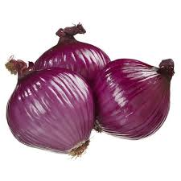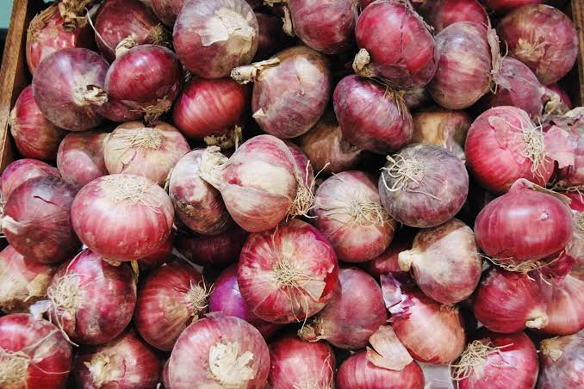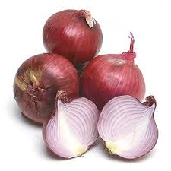

Lettuce

English samples

product name: Lettuce

product description: From a man made environment quality product. Kept fresh in a cool storage. Good quality, no pesticides, harvested on April 20, 2024. Green colored lettuce.

product price: ₱280

product type: Crops

product measurement: kilogram

product quantity: 30

product picture/image(3 samples different figures):

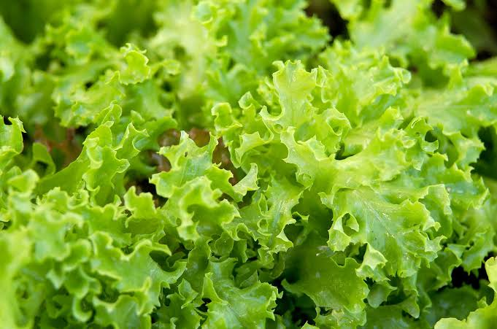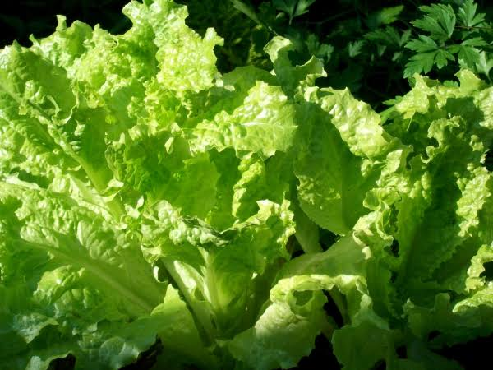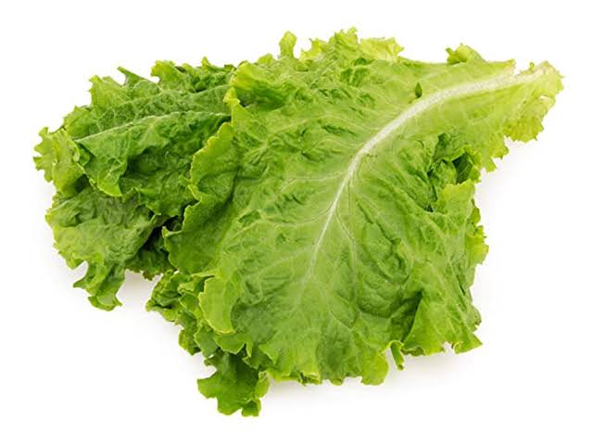

Kamote

English samples

product name: Sweet Potato (Kamote)

product description: From healthy soil of Mawab, Davao De Oro, Healthy and above average sizes. Good quality, harvested on March 10, 2024. Orangey colored

product price: ₱ 55

product type: Crops

product measurement: kilogram

product quantity: 45

product picture/image(3 samples different figures):

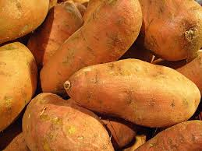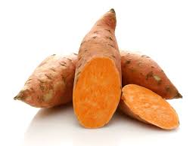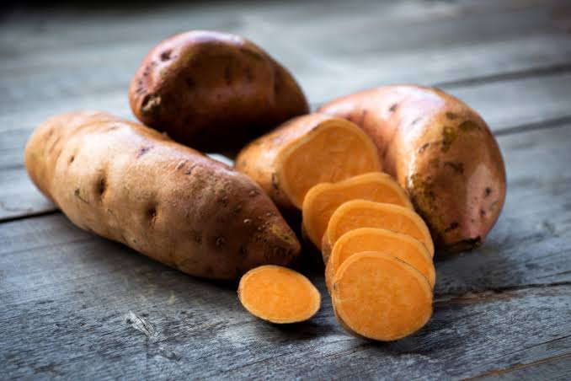

Durian

English samples

product name: Durian

product description: Type of Durian : Duyaya; known for its creamy texture and slightly bitter-sweet taste. Big Sizes, Good quality, harvested on April 1, 2024.

product price: ₱160

product type: Fruit

product measurement: pieces

product quantity: 55

product picture/image(3 samples different figures):

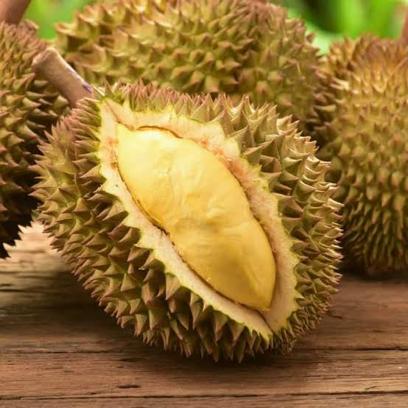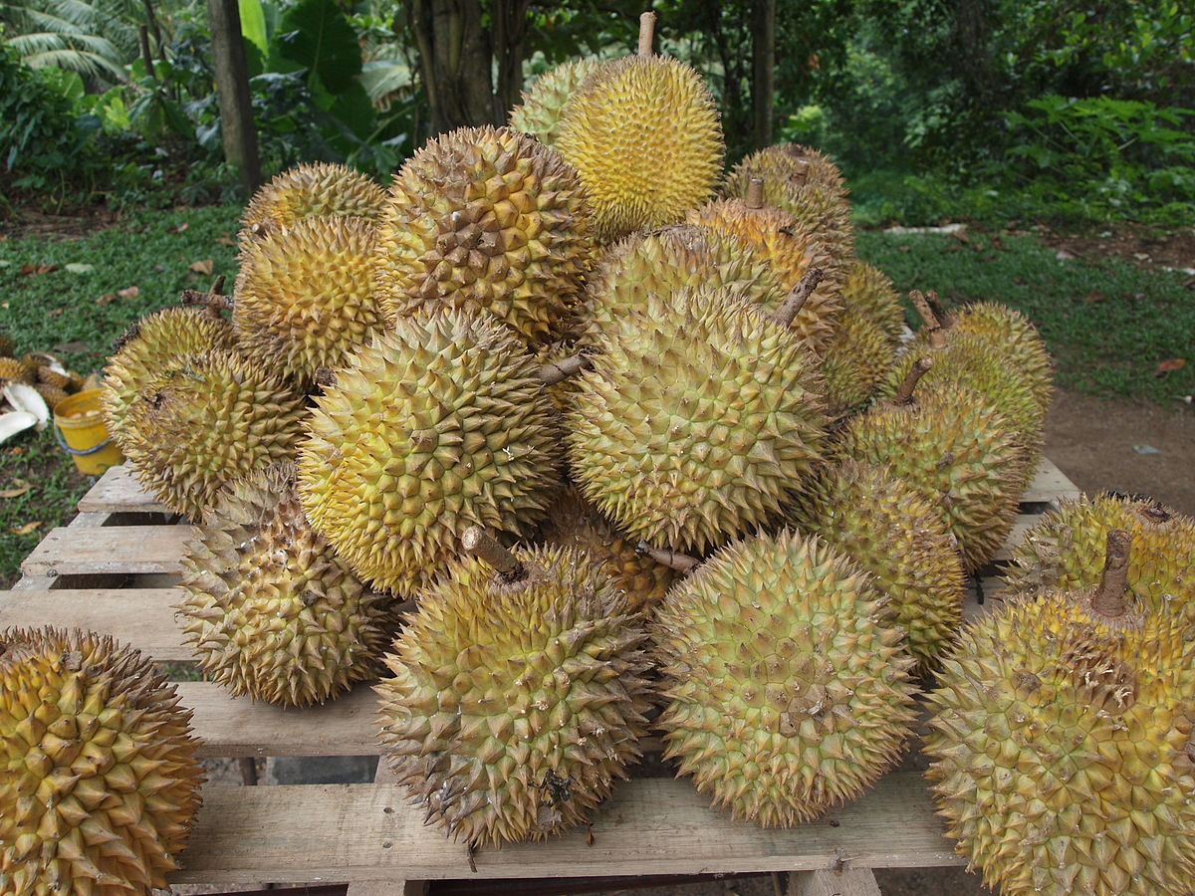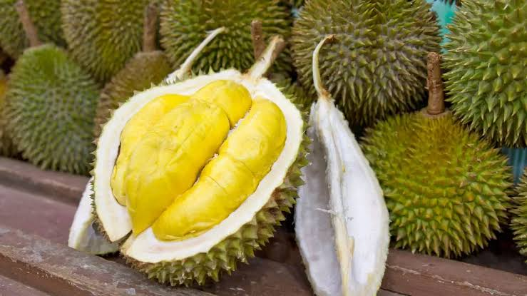

Pineapple

English samples

product name: Pineapple (Pinya/Piña)

product description: From the farm of DOLE; Sweet and tangy flavor and juicy. No chemicals used. Big Sizes, Good quality, harvested on April 20, 2024.

product price: ₱78

product type: Fruit

product measurement: pieces

product quantity: 104

product picture/image(3 samples different figures):

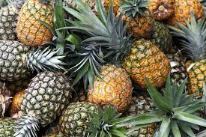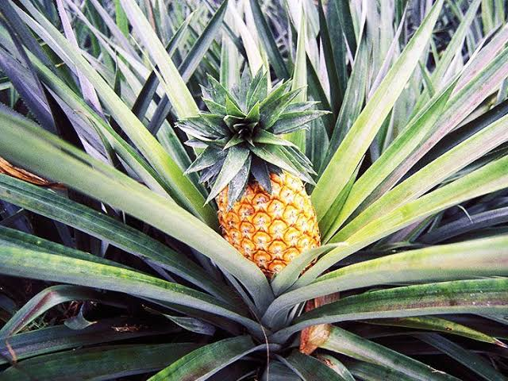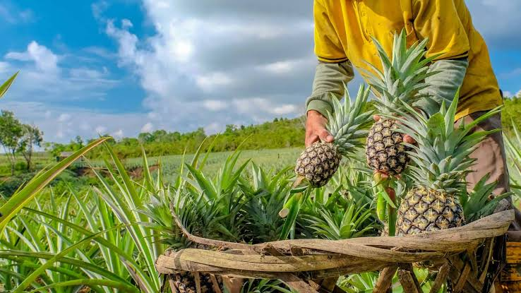

Cacao

English samples

product name: Cacao (Kakaw)

product description: From my beautiful farm in Asuncion. Sweet and no chemicals used. Big Sizes, Good quality, harvested on April 10, 2024.

product price: ₱45

product type: Fruit

product measurement: pieces

product quantity: 56

product picture/image(3 samples different figures):

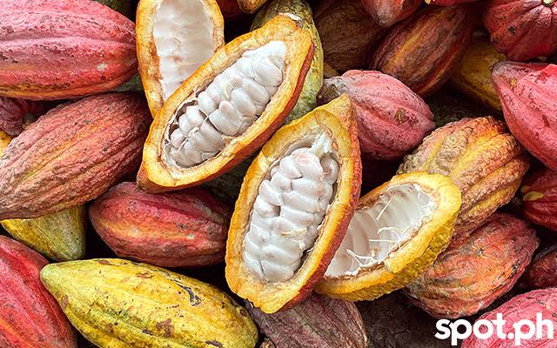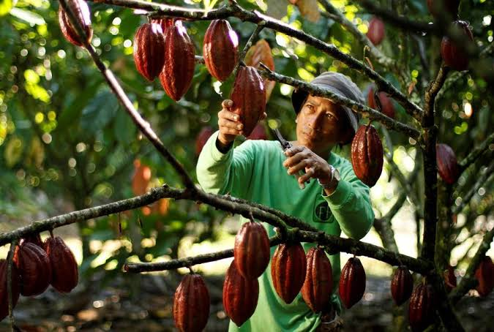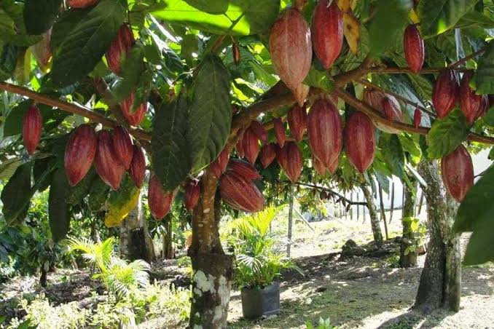

Coconut

English samples

product name: Coconut (Niyog/Lubi)

product description: From my farm in Mawab. Matured Type of Coconut (Brown). Normal Sizes, Good quality, harvested on March 02, 2024.

product price: ₱25

product type: Fruit

product measurement: pieces

product quantity: 201

product picture/image(3 samples different figures):

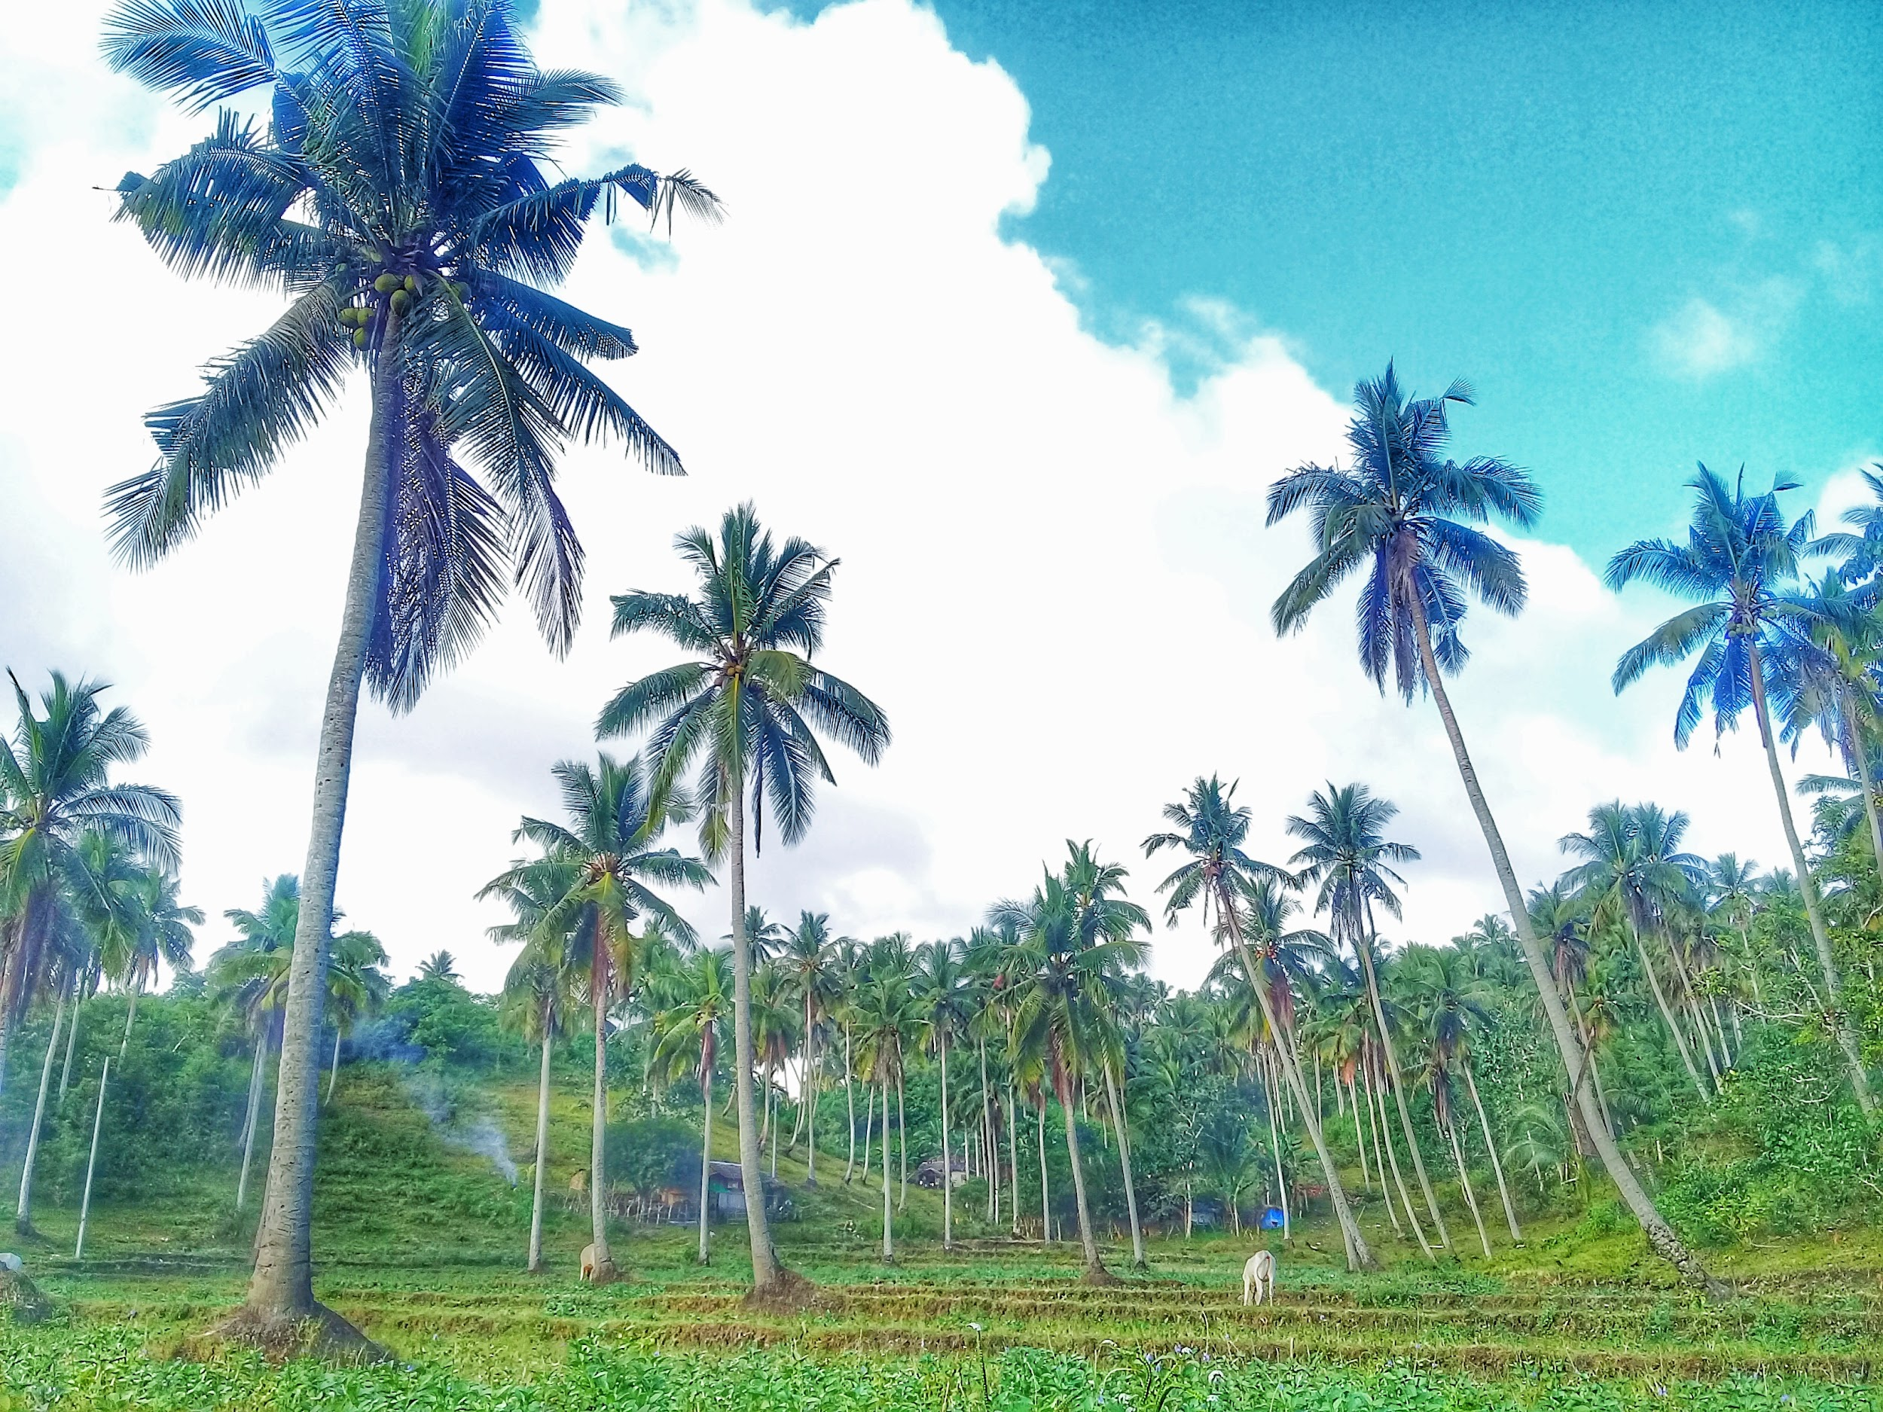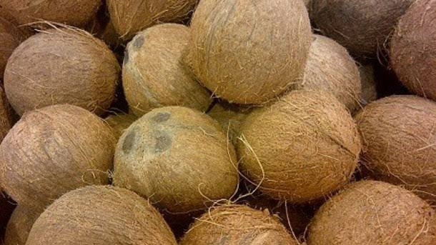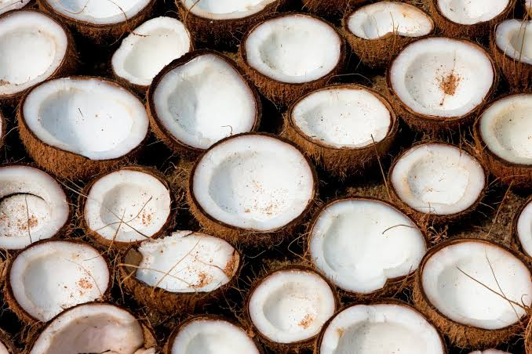

Mangosteen

English samples

product name: Mangosteen

product description: From my farm in USeP Mabini. Sweet and Normal Sizes, Good quality, harvested on April 10, 2024.

product price: ₱300

product type: Fruit

product measurement: kilogram

product quantity: 32

product picture/image(3 samples different figures):

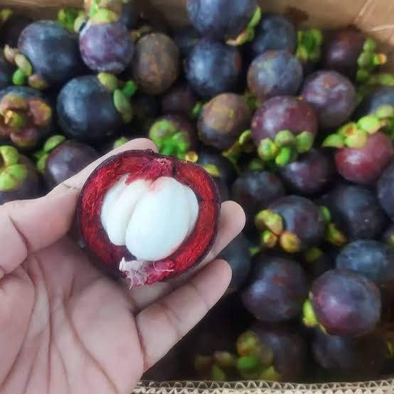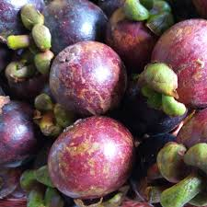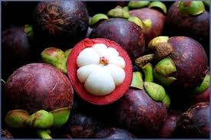

Ginger

English samples

product name: Ginger(Luya/Loy-a)

product description: From a farm in Tagum City. Big Sizes, No chemicals used. Good quality.

product price: ₱65

product type: Crop

product measurement: kilogram

product quantity: 30

product picture/image(3 samples different figures):

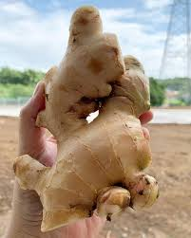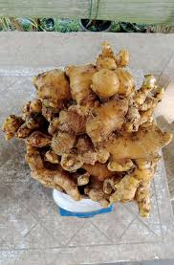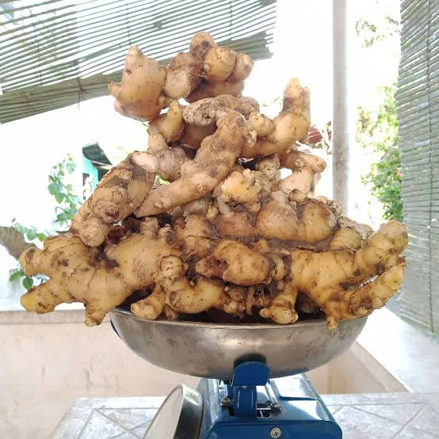

Goat

English samples

product name: Goat (Kambing/Kanding)

product description: Baby goats: 3 months - 5 months of age. Any gender is random. Good nutrition. You can leave a note for specific gender, age and weight. Location: Apokon, Tagum City.

product price: ₱2500

product type: Livestock

product measurement: pieces

product quantity: 9

product picture/image(3 samples different figures):

